“Consciousness” and Conceptual Learning
In A Socially Situated Agent

Myles Bogner, Uma Ramamurthy, and Stan Franklin

{mbogner,urmmrthy,stan.franklin}@memphis.edu
Conscious Software Research Group
Institute of Intelligent Systems
The University of Memphis

Abstract

This paper describes the architecture of a “conscious” software agent, Conscious Mattie, who is socially situated. We’ll focus on consciousness and conceptual learning. CMattie gathers seminar information via email from humans, composes an announcement of the next week’s seminars, and mails it to members of a mailing list that she maintains. Through further interaction with seminar organizers, CMattie learns new variations to seminars, such as a colloquium, that must also be announced, but is to be handled differently. In this paper, we discuss in detail the functionality of CMattie’s perception and consciousness modules that bring about socially situated intelligence. Using a limited capacity global workspace that coordinates with the perception module, CMattie communicates with human seminar organizers. Through such interaction CMattie gathers missing information and learns new concepts for use in composing the announcements. Here a “conscious” software architecture and its mechanisms are proposed as a method for designing and implementing useful, socially situated, software agents.

Introduction

Wheeler (technical report) argues that “orthodox cognitive science claims that situated (world-embedded) activity can be explained as the outcome of in-the-head manipulations of representations by computational information processing mechanisms.” He casts doubt on this assertion, pointing out the difficulty AI encountered “in moving from toy worlds to dynamic unconstrained environments,” and further argues that such difficulties are inevitable within the stated paradigm. Instead, he advocates systems that “exhibit dynamical profiles comparable to those displayed by biological neural networks, and … play the same adaptive role as biological networks, i.e., to function as the control systems for complete situated agents.” This view seems to us particularly relevant when applied to socially situated agents. Here we offer Conscious Mattie as a prototype of the type of biologically motivated system Wheeler spoke of, able to interact, adapt and learn in a social environment comprised of human agents. CMattie should be equally at home in a society of agents of her own type, or in a mixed society. In this paper we’ll describe CMattie, a “conscious,” socially situated, software agent, paying particular attention to her consciousness and conceptual learning mechanisms.
An autonomous agent (Franklin and Graesser 1997) is a system situated in, and part of, an environment, which senses that environment, and acts on it, over time, in pursuit of its own agenda. It acts in such a way as to possibly influence what it senses at a later time. In other words, it is structurally coupled to its environment (Maturana 1975, Maturana and Varela 1980). Biological examples of autonomous agents include humans and most animals. Non-biological examples include some mobile robots, and various computational agents, including artificial life agents, software agents and computer viruses. We’ll be concerned with an autonomous software agent, “living” in a real world computing system.
Autonomous software agents, when equipped with cognitive (interpreted broadly) features chosen from among multiple senses, perception, concept formation, attention, problem-solving, decision making, short and long-term memory, learning, emotions, etc., are called cognitive agents. Though ill defined, cognitive agents can play a synergistic role in the study of human cognition, including consciousness (Franklin 1997).
Here, we are particularly concerned with cognitive software agents that implement global workspace theory, a psychological theory of consciousness (Baars 1988, 1997). Global workspace theory postulates that human cognition is implemented by a multitude of relatively small, special purpose processes, almost always unconscious. It's a multiagent system with a society of its own. Coalitions of such processes, when aroused by novel and/or problematic situations, find their way into a global workspace (and into consciousness). This limited capacity workspace serves to broadcast the message of the coalition to all the unconscious processors, in order to recruit other processors to join in handling the current novel situation, or in solving the current problem. All this takes place under the auspices of contexts: goal contexts, perceptual contexts, conceptual contexts, and/or cultural contexts. Each context is, itself a coalition of processes. There's much more to the theory, including attention, learning, action selection, and problem solving.
We will refer to cognitive agents that implement global workspace theory as conscious software agents. Conscious software agents are domain-specific entities. They adapt and learn by reacting to the changes in their domain, and through their interaction with other agents in their domains, be they human or artificial. Due to this extensive interaction, conscious software agents tend to be social creatures, and exhibit some socially situated intelligence.
CMattie is such a conscious agent (Franklin and Graesser, forthcoming). Designed for a specific, narrow domain, she functions in an academic setting, "living" in a UNIX-based system. She gathers information from humans regarding seminars and seminar-like events such as colloquia, theses defense, etc. Using this information, she composes an announcement of the next week's seminars, and mails this announcement weekly to members of a mailing list that she maintains, again by email interactions with humans. CMattie uses short-term, intermediate and long-term memories. Her emotion module enables her to react to both internal and perceived events. Her sense of self-preservation underlies her concern about her resource needs and about the status of the UNIX-based system in which she "lives." By interacting with seminar organizers, CMattie learns new concepts and behaviors. Due to the nature of her domain, this learning occurs mainly through case based reasoning. Such learning mechanisms contribute to CMattie’s socially situated intelligence (SSI). She learns to react differently in different social situations.
Following the tenets of the action selection paradigm (Franklin 1995) as expanded into design criteria (Franklin 1997), CMattie is designed using a multiplicity of artificial intelligence mechanisms. Her modular architecture, as illustrated in Figure 1, implements and integrates these several diverse mechanisms. They include behavior networks (Maes, 1990) for action selection, sparse distributed memory (Kanerva, 1988) for long-term, associative memory, pandemonium theory (Jackson, 1987) for agent grouping, Copycat architecture (Mitchell, 1993; Hofstadter and Mitchell, 1994) and natural language understanding (Allen, 1995) for email comprehension, and case based memory (Kolodner, 1993) for intermediate term, episodic memory. Each of these mechanisms has been significantly extended in order to merge with the others, and to meet the needs of this domain. CMattie is the first software agent intended as an implementation of global workspace theory (Baars, 1988; 1997).
CMattie has several drives, some corresponding to her tasks (sending seminar announcements, reminding organizers to send information, and acknowledging messages). These drives are explicitly built into the agent, and operate in parallel. Some drives vary in urgency, an extension to Maes’ work. For example, the urgency level for sending out a seminar announcement will increase as the time to send the announcement approaches. Each drive activates behaviors that work to fulfill the drive.
Behaviors in CMattie (Song and Franklin, forthcoming) correspond to global workspace theory's goal contexts. Each behavior has an activation level affected by drives, other behaviors adjacent to it in the behavior net, internal conditions, and environmental inputs (the perception registers' contents). Only one behavior can be active at a time. A behavior’s activation is spread to those behaviors that can fulfill its unmet preconditions and to behaviors whose preconditions can be satisfied by this behavior. Each behavior can thus be considered part of a behavior stream. For example, there’s a behavior stream that composes the seminar announcement. One behavior in that stream might fill the Cognitive Science Seminar's portion of the seminar announcement.
CMattie’s emotions play two roles (McCauley and Franklin,1998). First, emotions indirectly affect a behavior stream’s activation level by affecting the strength of drives. Emotions allow CMattie to be pleased about sending out a seminar announcement on time and to be anxious about an impending system shutdown. In these cases, emotion might increase a behavior stream’s activation level since it is pleasing for CMattie to complete these streams promptly. Second, emotions influence the suggested actions that are the output of Sparse Distributed Memory. Therefore, CMattie may be more or less inclined to actively pursue a suggested action based on the action’s associated emotional level.

Overview of an Architecture for Supporting SSI
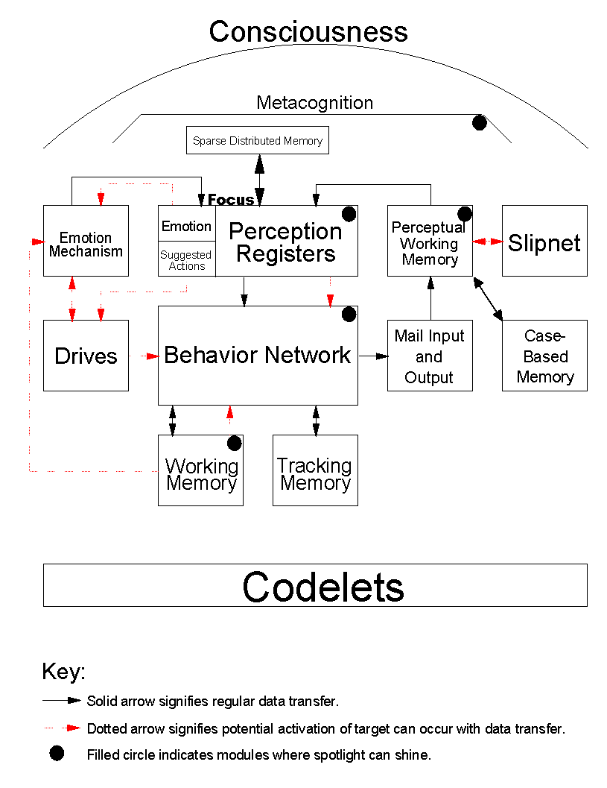
Figure 1: CMattie’s Architecture

Sparse distributed memory is a content addressable memory that serves as long-term, associative memory for CMattie (Anwar and Franklin, forthcoming). This memory stores the contents of the perceptual registers as well as her emotions and actions. Default information, such as time and room can often be recovered, contributing to the understanding of incoming messages. Recovering remembered emotions and actions helps with action selection in the new situation. The focus serves as the location from whence sparse distributed memory interacts with CMattie's other components.
By monitoring what’s in consciousness, the activation of drives, emotional states, parameters in the behavior network, and the perception module, metacognition keeps track of CMattie’s internal conditions (Zhang, Franklin and Dasgupta, in press). Using a classifier system (Holland, 1986), metacognition makes inferences about CMattie’s state. If necessary, it can influence consciousness, perception, learning, and the behavior network. For example, metacognition can change the behavior network's activation level threshold to make the agent more goal-oriented or more opportunistic. It can cause voluntary attention by influencing the activation levels of certain coalitions of processors. Metacognition plays the role of an overseer, trying to keep CMattie’s action selections on a productive track.
CMattie’s tracking memory stores templates used in composing outgoing email messages of different types. It also keeps track of the current seminar announcement mailing list. As of now, the tracking memory also stores default information on seminars, such as the day of the week each one occurs. This function will probably be subsumed by associative memory.
All outgoing messages are composed in the composition workspace. Message composition consists of filling the fields of an outgoing message template. The information used to fill these fields comes from the perception registers and any of associative, case based, or tracking memories. A current seminar announcement template is always being generated in the composition workspace. As new information is perceived and placed in perception registers, the template fields are filled. When a seminar announcement is mailed, a new announcement template is placed in the composition workspace.
The mail-input and mail-output portion of the agent receives incoming email messages and the sends outgoing ones. Incoming email messages are first received by the mail-input portion and are moved from there to the perception module. Once an outgoing message is fully composed, it is moved to the mail-output portion and sent.
CMattie’s sensory data are, for the most part, the incoming email messages she receives. Perception for the agent occurs when she comprehends such a message. CMattie’s perception is described in more detail in the next section.
The real work of almost all of CMattie’s modules is performed by codelets (Hofstadter and Mitchell 1994). This includes her behavior network, emotion, metacognition, perception, and portions of consciousness. Each codelet can be thought of as a small distinct agent designed to perform a single task. For example, one perceptual codelet’s task is to place the seminar speaker's name in the appropriate perception register. CMattie’s codelets correspond to processors in global workspace theory and to the demons of pandemonium theory. Codelets coalesce into coalitions, become conscious, broadcast their information to all other codelets in the system, and receive the conscious broadcast. CMattie, following yet another tenet of the action selection paradigm, is very much a multi-agent system.
Learning via several types of mechanisms allows CMattie to become more closely coupled to her environment. She can learn new behaviors, for example, a new step in preparing for a system shutdown. She might also learn a new strategy for sending out reminders to seminar organizers. Much of her learning uses case based reasoning. She learns new concepts in her slipnet allowing her to better understand incoming messages. This learning will be described in detail later. CMattie creates (learns) new codelets by modifying existing codelets enabling her to perform the newly learned behaviors and perceptual techniques. Coalitions of codelets will also be learned via association a la pandemonium theory (Jackson, 1987). This allows the agent's codelets greater ease in communicating and recruiting other codelets to help in performing tasks. Associative learning also occurs in sparse distributed memory as actions, events, and emotions are associated with one another when placed in this memory.
CMattie also contains a global workspace based on Baars’ theory of consciousness. This allows the agent to focus attention on a specific situation. The agent’s consciousness module will be described in detail below.

Perception

The perception module in CMattie was inspired by and can be thought of as an extension of the Copycat architecture (Mitchell, 1993). Copycat is based on the premise that analogy making is a process of high-level perception, and that analogy making lies at the core of understanding. Copycat makes and interprets analogies between situations in a microworld of letter-string analogy problems. Copycat's domain is predefined and fixed; therefore, there is no learning. Since CMattie "lives" in a dynamic domain, her perceptual learning mechanism enables her to perceive this dynamism.
CMattie's perception involves building instances of known concepts in her domain; learning, detecting and creating new concepts; and making appropriate relations between those concepts. Her perception module consists of mail input and output, the slipnet, working memory and case based memory.

Mail Input and Output. These provide CMattie's interface to her domain. Using this unit, she receives and sends out email messages related to seminars, seminar-like events such as colloquia, and maintenance of the recipient mailing list. Mail input and output can process more than one email message at a time, enabling the perception module to perceive and understand emergency events in CMattie's world. This aids in maintaining her sense of self-preservation as she proactively reacts to her changing resource needs. She immediately reacts to the status of the UNIX-host system wherein she "lives".

Slipnet. The slipnet is a network of nodes and links representing the CMattie’s permanent perceptual concepts. A concept has a core and a set of features representing its basic characteristics. In a given context, a feature might have a specific value. In CMattie, concepts are often defined by a region of nodes and links in the slipnet. Each of the concepts in the agent may be an individual node or group of nodes. The various nodes are connected to each other through weighted links.

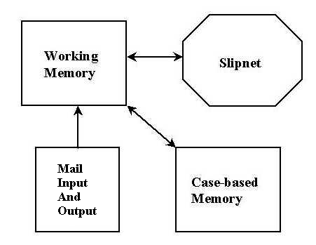
Figure 2: Conscious Mattie's Perception Module

One of the built-in concepts in the perception module is the Seminar concept with the following features:
Name of the Seminar
Organizer of the Seminar
Location where the Seminar is to be held
Date of the Seminar
Day of the week of the Seminar
Time at which the Seminar is to be held
Speaker of the Seminar
Title of Talk for the Seminar
Periodicity of the Seminar

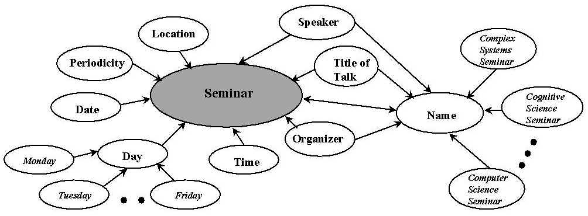
Figure 3: Segment of the Slipnet in the Perception Module

Name and Day are features of the Seminar concept, and they are concepts themselves, each with a separate set of features. Seminar concept is deeper than the Name and Day concepts and has a higher depth value than those two concepts. Depth values aid in the assignment of node activation level.
Each node in the slipnet has one or more codelets associated with it. When an email message is received by mail input, these codelets aid in understanding the message, which is written in natural language (Zhang et al, 1998). They recognize relevant words and phrases in the received message, and send activation to the appropriate slipnet nodes. A corpus of email messages collected for two years contributed to the building of the slipnet.

Working Memory. This memory holds the contents of the incoming email message. It also holds the perception process' intermediate results, as codelets associated with slipnet nodes operate inside working memory to understand the received email message. The most significant inference made in this process is the categorization of the type of the incoming message.

Case Based Memory. Case based memory constitutes CMattie's episodic memory. In it she stores the sequences of email messages that form episodes. This allows her to relate new events to similar past events. She understands these past events using her built-in domain knowledge. Case based memory aids her in learning new slipnet concepts through case based reasoning. This memory acts as an intermediate term memory, and the information stored there is used to learn domain knowledge.

Perception Process

When an incoming message is understood, every significant word or phrase has been given a field name, and the type of the email message has been inferred. This information is then transferred by perceptual codelets to the perception registers in the focus. Some of the perception registers are Name, Organizer, Location, Date, Day, Time, Speaker, Title-of-Talk, Periodicity, and Message Type. Other perception registers hold previously unencountered words and phrases that occur in the received email messages and that might be relevant. The perception process is complete when the type of the received message has been inferred and the understood information regarding the received message has been transferred to the perception registers.

Bringing the Focus to Consciousness

Many of CMattie’s components use information from the focus. This section describes how the focus is used to bring perceived information into consciousness. The focus includes five vectors: the perception registers, the output of sparse distributed memory, the input to sparse distributed memory, the output of case based memory, and the input to case based memory. The Perception module places the components of the understood email message into the perception registers. That constitutes the current percept. Next, sparse distributed memory is read with the current percept as the address. Also, case-based memory is read with the same address. These reads are designed to gather the information most relevant to what was just perceived.
A consciousness codelet is one whose function is to bring specific information to consciousness (Bogner, 1998). In particular, after the memory reads, some consciousness codelets bring information from the focus to consciousness. One such consciousness codelet is associated with each of the perception registers and carries the specific piece of perceived information from that register. For example, one codelet carries the speaker’s name, and another carries the seminar’s time. In addition, some consciousness codelets check for conflicts amongst the relevant items returned from the percept and the memory reads. For example, a conflict occurs if the perceived place, time and date for the Cognitive Science Seminar are the same as case based memory’s output of these same features for the Graph Theory Seminar. The consciousness codelet recognizing the conflict raises its activation level. Simultaneously, it begins to gather a coalition of the other consciousness codelets carrying both the perceived and conflict information by increasing their activation levels. Once this coalition of codelets reaches consciousness, the perceptual information along with the conflict is broadcast to the entire system, that is, to every unconscious codelet.

Consciousness

CMattie’s global workspace gives the agent several important performance features. It allows for coalitions of codelets to gain attention. Information about these codelets is broadcast to all of the agent’s other codelets. Recipients of this broadcast become active themselves if enough of the information is understood, and if it is applicable. In this way, the broadcast recipients have the potential to contribute towards solving the problem raised by the conscious coalition. This broadcast also allows metacognition a view of the events taking place in the system. Learning also uses the information in consciousness to learn to associate codelets as a coalition. In addition to consciousness codelets, the consciousness module consists of four major components: the playing field, the coalition manager, the spotlight controller, and the broadcast manager.

CMattie’s Playing Field

Artificial Minds (Franklin, 1995) contains a detailed summary of pandemonium theory first described by Oliver Selfridge in 1959 for perceptual uses and extended by John Jackson in 1987 to an “idea for a mind.” (Jackson, 1987). Pandemonium theory's components interact like people in a sports arena. Both the fans and players are known as demons. Demons can cause external actions, they can act on other internal demons, and they are involved in perception. The vast majority of demons are the audience in the stands. There are a small number of demons on the playing field. These demons are attempting to excite the fans. Audience members respond in varying degrees to these attempts to excite them, with the more excited fans yelling louder. The loudest fan goes down to the playing field and joins the players, perhaps causing one of the players to return to the stands. The louder fans are those which are most closely linked to the players. There are initial links in the system. Links are created and strengthened by the amount of time demons spend together on the playing field and by the system's overall motivational level at the time.
CMattie uses pandemonium theory's notion of a playing field. A collection of codelets which act as demons are instantiated when the program first runs. Each of these is a generator codelet of a specific codelet type. If a codelet of one of these types is to become active as a result of having received information broadcast from the conscious coalition, the appropriate generator codelet instantiates a copy of itself with the relevant information. This allows for multiple codelets of the same codelet type to run in parallel, each working with different information, These generator codelets can be considered fans in pandemonium theory's arena.
All codelets, other than these generator codelets, are considered active, and are either performing some function or are waiting for the opportunity to perform its function to occur. These active codelets are pandemonium theory’s players on the playing field. The playing field is a shared space in memory; all active codelets exist in this shared memory space.
Codelets on the playing field may be associated with one another. Some of these links are built in. For example, codelets underlying the same higher level concept, such as a behavior, are likely to be associated with one another. Codelet associations also develop when codelets are together in consciousness. This illustrates one point of difference with pandemonium theory. There, association arises or is strengthened from being together in the playing field. Here, it’s from being in consciousness together.
Codelets have a two-part name. The first portion signifies from where a codelet on the playing field is derived, such as a particular behavior. Since there can be multiple codelets of the same type active, codelets also carry a unique identification number. Codelets on the playing field have an activation level, which may come from the higher level construct from which they were instantiated, for example from a behavior, a slipnet node or an emotion. Consciousness codelets provide their own activation. Activation normally decays over time. The activation level of codelets is an important factor in deciding which coalition gains conscious attention.
Figure 4 illustrates CMattie's playing field. Two components of her global workspace implementation, the coalition manager and the spotlight controller, play important roles on the playing field.

Figure 4: Conscious Mattie’s Playing Field

Coalition Manager

The coalition manager groups active codelets into coalitions, and keeps track of them. To make coalitions, the coalition manager groups codelets according to the strength of the associations between them. Only if a collection of codelets is associated above a certain threshold level are they considered to be in a coalition. In particular, the collection of codelets associated with a single higher level concept may or may not form a coalition. As a codelet can serve more than one higher level concept, so may it belong to more than one coalition.
The playing field provides an active dynamic environment. The activation level of codelets decay. Newly activated codelets join existing coalitions. Codelets leave one coalition and possibly join another. The strength of a codelet's association to its higher level concept may change. Due to this dynamic environment, the coalition manager must continually and efficiently survey the playing field to keep its record of coalitions up to date.

Spotlight Controller

The spotlight controller determines which coalition becomes conscious. It calculates the average activation level of each of the coalitions by averaging the activation levels of the coalition's codelets. The spotlight shines on the coalition with the highest average activation level. Average activation among a coalition's codelets, not the total activation, is taken to prevent larger coalitions from having an advantage over smaller ones. In the same way as the coalition manager’s, the spotlight controller's domain is extremely dynamic. Here are some instances. An activation level goes to zero when an instantiated codelet’s work is complete. A consciousness codelet may greatly increase its activation when it, say, finds a conflict. A behavior being chosen sends new activation to each of it underlying codelets. And so on.

Broadcast Manager

Once the spotlight controller has determined a conscious coalition, it notifies the broadcast manager who is responsible for gathering information from the conscious coalition, and sending it to all of CMattie's codelets. As in global workspace theory, messages are small and understood by only some of the agent's codelets.
Specifically, from the conscious coalition the broadcast manager gathers objects labeled for broadcast, that is, those that contain information needed for specifying the current novelty or problem. This information is then broadcast to all of CMattie's codelets. This is accomplished via a blackboard model. Information gathered from a coalition is placed on the blackboard, implemented as a shared memory space. When each codelet polls this blackboard, it searches for parameters it understands. Information is left on the blackboard for a significant time period so that all codelets receive the broadcast as specified in global workspace theory.

Consciousness as a Facilitator for Learning

The conscious broadcast recruits codelets that understand the message and for which it is relevant. This causes their activation to increase, motivating them to begin performing their respective tasks. These tasks might include activating their overlying higher construct, say a behavior, an emotion, a slipnet node, a learning mechanism. Figure 5 illustrates the significant role of consciousness in perceptual learning, highlighting global workspace theory's premise that consciousness is sufficient for learning. This section focuses on the perceptual learning that results from the conscious broadcasts.
CMattie has a limited number of seminars already defined in her slipnet. She "knows" about these seminars through the built-in seminar concept and its features. In particular, she knows that:
- A seminar is held once a week
- It has an organizer and a name
- Each week, there might be a different speaker
- It has a different title-of-talk
- It is usually held at the same location, on the same day of the week, and at the same time.
Suppose a seminar organizer sends her a message announcing a seminar with a seminar name that she has never seen before. CMattie attempts to treat such a message in a way similar to seminars that she already knows. The learning mechanism described here is based on the premise that any agent, including humans, learns based on what it already knows. When the message understanding mechanism attempts to understand this message, the agent recognizes that it is an initiate-seminar-message for a seminar, but that the name of this seminar is not part of the built-in knowledge. This information is placed into the perception registers, brought to consciousness, and broadcast. CMattie has codelets that understand this broadcast and can activate behavior streams that act to converse with the sender of the message to determine if the sender wishes to initialize a new seminar. She sends an acknowledgement to the sender stating that a new seminar with that seminar name will be initialized, with the sender as its organizer and requesting confirmation. Reinforcement of a sort is provided to CMattie by the response she might or might not

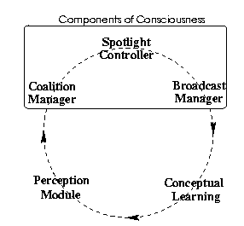
Figure 5: Consciousness As A Facilitator For Conceptual Learning

get. Based on the conscious broadcast of this feedback, if any, a new slipnet node is created for this seminar name, and it is linked to the name node, which is also a feature of the seminar concept. When this new node is generated, the associated codelets for it are generated as well, a quite straightforward process. The new codelets are based on similar, existing codelets for the other name nodes. Once the process is complete, CMattie has understood the incoming confirmation message, and the perception module sends the relevant fields to the perception registers.
The second type of learning that takes place in the perception module occurs when CMattie learns concepts which are not completely identical to the built-in seminar concept, but slightly different from it. In her domain, colloquia, dissertation defenses, dissertation committee meetings, and faculty meetings, all fall into this category. This second learning mechanism is based on viewing every new situation in terms of a previously solved problem (analogy making). When CMattie receives a message about such a non-seminar event, say a dissertation defense, she treats it as a speaker-topic message for a seminar. This understanding is disseminated through consciousness. The agent sends an acknowledgement to the sender stating that she is initializing a new seminar by the name "Dissertation Defense Seminar" with the sender as organizer. This misunderstanding can be expected to result in one or more of the following events, depending on the sender.
- The acknowledgement elicits a negative response from the sender, starting an episode. The resulting "conversation" between CMattie and the sender is stored in case based memory. This episode provides information that allows CMattie, even with her limited natural language understanding, to learn that dissertation defense is similar to the seminar concept, but with slightly different features. In this case, the periodicity feature has a different value. CMattie learns this through case based reasoning.
- The sender ignores the acknowledgement, and CMattie includes the Dissertation Defense Seminar in her weekly seminar announcement. In this case nothing is learned at this time, but perhaps later.
- CMattie includes the Dissertation Defense Seminar in seminar announcement. This action is likely to elicit a negative response from the sender, starting an interaction with CMattie. This episode again is stored in case based memory to aid her in learning what a Dissertation Defense is.
- The sender might also ignore the incorrect weekly announcement, but respond to the reminder sent by CMattie the following week, when she doesn't receive a speaker-topic message for the Dissertation Defense Seminar. This, again, generates an episode allowing CMattie to learn about a Dissertation Defense.
- The sender ignores all the reminders. In this case, ignoring the reminders itself acts as feedback to CMattie, giving rise to a new concept that is similar to the seminar concept with its periodicity feature modified.
Regardless of which of these scenarios occur, CMattie eventually learns a new concept called dissertation defense that is closely related to the seminar concept. Note that this conceptual learning takes place through the internal interaction between consciousness and perception. Each of these possible situations becomes conscious before any changes to the perception module occur. Also note the crucial role in this conceptual learning played by external social interaction with a human.
How is all this done? There are two main capabilities. First, CMattie has codelets in her slipnet that look for words and phrases that she hasn’t previously encountered. The perception module tracks such new words and phrases that occur with any regularity by keeping statistics and recognizing novelty. This aids in CMattie's natural language understanding. Second, even with her limited natural language understanding, CMattie can understand messages from organizers that have negative connotations. Her slipnet has nodes and codelets that detect words and phrases with such negative connotations.
Consider a possible path CMattie might take during her conceptual learning. CMattie misunderstands the first dissertation defense message, and sends an acknowledgement to the organizer for a Dissertation Defense Seminar. Suppose the organizer responds with a negative message saying, "It is not a seminar, but a dissertation defense". CMattie understands the negative connotation in "not a seminar" and the repeated occurrence of the phrase “dissertation defense” activates her questioning capability to send a message to the organizer with the question, "What is a dissertation defense?” The organizer might reply with a simple explanation such as, "A dissertation defense is like a seminar, but it might not occur regularly" or "Dissertation defenses do not ordinarily occur every week". CMattie understands the negative connotations in relation to the words "regularly," "every week" or "weekly". These are keywords in the slipnet related to the periodicity features of the seminar concept. CMattie uses her case based memory and natural language understanding to reason that a dissertation defense has a periodicity different from that of a seminar. This interaction with the organizer and her reasoning effects the creation of a new concept, dissertation defense, in the slipnet with related codelets that search for it in future messages. This conscious learning enables her to correctly perceive and understand a dissertation defense message when next she encounters one. Of course, CMattie must also learn to behave differently when faced with a dissertation defense message that she does with a seminar message. But, that’s a subject for another article.
A trace of this learning stored in her case based memory serves to enhance her case based reasoning capabilities. Later, CMattie might encounter a colloquium message, and in response to her incorrect acknowledgement of a Colloquium Seminar, be told that "It is a colloquium, not a Colloquium Seminar". CMattie's case based reasoning depends on (a) past experiences she has had, and (b) her ability to understand new situations in terms of her past experiences. She recalls her experience with the first dissertation defense message from her case based memory, and reasons that colloquium might be similar to dissertation defense. She sends a message to the organizer with the question, "Is a colloquium similar to a dissertation defense?” Her understanding and reasoning, based on the organizer's reply to her query, aid her in learning about colloquia.
Thus CMattie’s conceptual learning is socially situated through her conscious interaction with seminar organizers. This interaction enables her to acquire a measure of socially situated intelligence.

Conclusions

This paper presents an overview of CMattie’s architecture focusing on consciousness and conceptual learning. The two modules implementing these contribute to the implementation of global workspace theory, and allow her to interact intelligently with seminar organizers. This interaction succeeds due to the unique integration of these two modules. Perceptual output enters the focus, which is brought to consciousness. The global workspace broadcast allows for conscious conceptual learning, completing the cycle. This cycle allows CMattie to acquire her socially situated intelligence. In particular, we hope to show that conscious software agents can be capable of essentially one-shot learning through interaction with a human.
Design and development of CMattie has been ongoing for several years. At this writing, the agent is into the implementation stage. In future stages, extensions such as unlearning are planned. CMattie is the first software agent designed to implement global workspace theory. As such, she can be considered the first “conscious” agent. It is hoped that the implementation decisions both provide testable hypotheses to neuroscientists and cognitive scientists, and that successful results will lead to more intelligent conscious agents. Most such are likely to be socially situated.

References

Allen, J. (1995). Natural language understanding. Redwood City, CA: The Benjamin/Cummings Publishing
Company, Inc.
Anwar and Franklin (forthcoming ????), “Sparse Distributed Memory for Conscious Software Agents”
Baars, B. (1988). A Cognitive Theory of Consciousness. Cambridge University Press, New York.
Baars, B. (1997). In the Theater of Consciousness. Oxford University Press, New York.
Bogner, M. (1998). Creating a conscious agent. Unpublished master’s thesis, The University of Memphis.
Franklin, S. (1995). Artifical Minds. The MIT Press, Cambridge, Massachusetts.
Franklin, S. (1997). Autonomous agents as embodied AI. Cybernatics and Systems, special issue on
Epistemological Issues in Embodied AI, 28, p. 499-520.
Franklin, S. and Graesser, A. (1996). Is it an agent, or just a program?: A taxonomy for autonomous agents.
Proceedings of the Third International Workshop on Agent Theories, Architectures and Languages,
Springer-Verlag.
Franklin, Stan and Graesser, Art (forthcoming), “Models of Consciousness”
Hofstadter, D. and Mitchell, M. (1994). The copycat project: A model of mental fluidity and analogy-making. In
holyoak, K. and Barden, J., editors, Advances In connectionist And Neural Computation Theory, volume
2: Analogical Connections, Norwood, NJ. Ablex.
Holland, J. H. (1986), “A Mathematical Framework for Studying Learning in Classifier Systems.” In D., Farmer et al, Evolution, Games and Learning: Models for Adaption in Machine and Nature. Amsterdam: North-Holland
Jackson, J. V. (1987). Idea for a mind. SIGGART newsletter, 101:23-26.
Kanerva, P. (1988). Sparse Distributed Memory. MIT Press, Cambridge, M.A.
Kolodner, J. (1993). Case-based Reasoning. Morgan Kaufmann Publishers.
Maes, P. (1990). How to do the right thing. Connection Science.
Maturana, H. R. (1975). “The Organization of the Living: A Theory of the Living Organization. ”International Journal of Man-Machine Studies, 7:313-32.
Maturana, H. R. and Varela, F. (1980). Autopoiesis and Cognition: The Realization of the Living. Dordrecht, Netherlands: Reidel.
McCauley, Thomas L. and Stan Franklin (1998) “An Architecture for Emotion,” AAAI Fall Symposium "Emotional and Intelligent: The Tangled Knot of Cognition"
Mitchell, M. (1993). Analogy-making as perception. MIT Press.
Song, Hongjun and Stan Franklin (forthcoming), “Action Selection Using Behavior Instantiation”
Wheeler, Michael (technical report), “For Whom The Bell Tolls? The Roles of Representation and Computation in the Study of Situated Agents,” Cognitive Science Research Paper 320, School of Cognitive and Computing Sciences, University of Sussex.
Zhang, Zhaohua, Stan Franklin and Dipankar Dasgupta (in press), Metacognition in Software Agents using Classifer Systems, Proc AAAI 98,
Zhang, Zhaohua, Stan Franklin, Brent Olde, Yun Wan and Art Graesser (1998) “Natural Language Sensing for Autonomous Agents,” Proc. IEEE Joint Symposia on Intelligence and Systems, Rockville, Maryland, 374-81

With essential contributions from the Conscious Software Research Group including Art Graesser, Derek Harter, Arpad Kelemen, Lee McCauley, Aregahegn Negatu, Fergus Nolan, Hongjun Song, and Zhaohua Zhang
Supported in part by NSF grant SBR-9720314
Supported in part by Cancer Center Support CORE Grant, P30 CA 21765 and by American Lebanese Syrian Associated Charities (ALSAC)
Supported in part by NSF grant SBR-9720314 and by ONR grant N00014-98-1-0332

